 **PARAKRAM 2018**



Robotics Club

**Presents**

**WILD SOCCER**

(Mannual Robotics Competition)

**Quote:**

“Success is no accident. It is hard work. Perseverance, Learning, Studying, Sacrifice and most of all, love of what you are doing or learning to do.

-Pele ”

**About:**

Everything is fair in love, war and soccer. Humans play, compete, excel and strike to win. But wouldn’t it be interesting to see machines do the same. This summer fierce and furious robots will increase the heat, fighting for goals and points. Manually controlled robots will fight for glory, in this exciting event.

**Problem Set:**

Participants will have to make soccer playing robots to take part in this event. Each side will have one defender and one attacker. Two teams can team up to compete in the event. The teams will have to play wild soccer to score maximum number of points. Team with the highest score will be declared the winner.

**Rounds and Details:**

This event will be conducted in two stages:

1. **Qualifiers:**

These matches will be league matches, after all the matches are held, top four teams will qualify for the next round. The top teams will be selected according to their scores in the qualifiers.

1. **The Final Battle:**

In this round, the finalists will compete with each other in knock-out matches there will be two semi-finals and one final. There will be a tie breaker for the third position.

**General Rules:**

1. A team can have **5** members at most.
2. Team has to be present at the arena **10 minutes** before game starts. Absence will result in direct disqualification of the team.
3. One person cannot be part of two teams.
4. Only one person from the team can control the robot at one point of time.
5. Participants are advised to bring their own extensions for power supply.
6. The robot must not draw more than **60watts** of power from the power supply, in case of wireless robot, battery of more than **3.2Ah** is not allowed.
7. Duration of qualifying matches will be **10 min** and there will be **BREAK** of **4 min.**
8. The robots shall be inspected before the event. Failing the inspection shall lead to disqualification.
9. Participants should not disassemble their robots until results are announced.
10. The organizers reserve the right to change the rules as they deem fit.
11. Practice arena will not be provided to the participants before the event starts.
12. In case the game ends up in a dead lock where the bots or the ball are stationary in the arena for mor than 15 seconds, the timer will be paused and the game will resume with both bots at their respective D areas.
13. Both the teams can request for one time out of no more than 2 min in duration, and for every extra **time out** there will be penalty of 20points for every 2 min.
14. Judges decision will be final.

**Judging Criteria:**

1. **100** points will be awarded for scoring each goal.
2. **50** points will be awarded to the attacker for immobilizing the opponent’s

robot

with its **FIRST** **ATTACK.** However the defending team will be given 5 min

to repair their robot if such a condition arises.

1. A penalty of **10** points will be awarded, if the goalkeeper crosses the **D.**
2. If a robot moves away from ball with an intention of attacking another robot,

the match referee shall award the team a penalty of **20** points.

1. Arena damage will cause a penalty of **100** points.
2. Wire damage will result in a penalty of **50** points.
3. The following actions are categorized as **HUMAN INTERVENTION**

resulting in a penality of **10** points:

* If a robot gets toppled in the arena.
* If a robot gets out of the arena.
* If the wire gets stretched.

**FAQs:**

1. **What is the maximum allowed weight for participating robots?**

The maximum permissible weight of the robot is 5 kg for wireless robots and 3.5 kg for wired robots.

1. **What are the maximum allowed dimensions of the robots?**

The maximum permissible dimensions of the robot are 35cmx30cmx30cm.

1. **What types of weapon systems can be used in the event?**

Pneumatic/Hydraulic/Cutter/Projectile/Entanglement etc. mechanisms are NOT allowed.

**Reference Arena:**

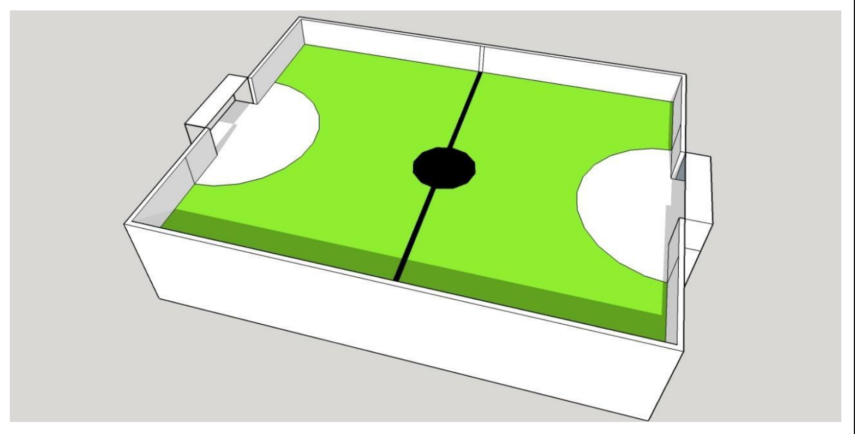

**Contacts:-**

Asheesh Raikwar (E.C.E 3rd yr) (+91-9151479272)

Shretika Jain (E.C.E 3rd yr)

Ankur Singh (E.C.E 3rd yr) (+91-7985349172)

Chandan Jaiswal (E.C.E 3rd yr) (+91-7786040495)

**Prize Money:**

**1st – 3,000**

**2nd – 2,000**

**3rd – 1,000**